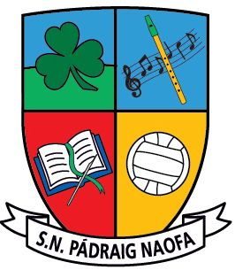

**St. Patrick’s, National School, Frenchpark**

**Our School Uniform**

**Please ensure that the correct uniform is worn to school every day**

**No clothing with brand names to be worn to school as part of uniform**

Navy Jumper – V-neck or round neck.

Navy trousers / pinafore / skirt (navy tights/ socks).

Light blue shirt / polo shirt.

**Black/navy runners**  It is preferable that runners are worn every day. It is the safest footwear for children on the yard, for playtime and for PE lessons with teachers and coaches.

PE days – plain navy tracksuits can be worn (no brand names) (no skinnies).