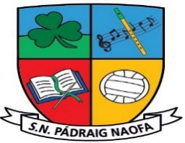

***3rd and 4th Class School Supplies 2024-2025 ~ Mrs. Cullinan***

|  |
| --- |
| School homework journal, art supplies, photocopying etc. **€25 per child, family of 2 €45, family of 3 or more €60.** |
| 1 A4 Zip Mesh Folder (Homework Folder)  5 A4 Plastic Workbook Covers  10 Copy Covers  Display Folder (20/40 pockets)  2 Card Document Wallet Folders  Tin Whistle - Key of D  Headphones/Earphones – Wired & iPad compatible (in a Ziplock bag with name)  Calculator  Reusable Water Bottle  Activity/Colouring Book for wet days. (This does not need to be new, any one from home is fine.)  2 HB Pencils  2 Red Pens  2 Blue Pens  2 Whiteboard Markers  2 Highlighters  Eraser, Sharpener, Long Ruler (30cm)  Twistables  2 Large Pritt-Stick Glue Sticks |

**Children in Fourth Class will have a lot of the above items already from Third Class.**

**Please label all belongings sent to school** – pencils, colours, jumper, jacket etc.

**Our School Uniform**

**Navy Jumper with School Crest** V-neck or Round neck (No hoodies)

**School Crests €5** available in the office.

**Navy Trousers** (no tracksuits)**/Pinafore/Skirt** (Navy tights/Socks)

**Light Blue Shirt/Blouse/Polo shirt**

**Black/Navy Runners** (It is preferable that runners are worn to school every day as they are the safest footwear for children on the yard.

PE Days – Plain navy tracksuit bottoms can be worn (no skinnies.)

**No clothing with brand names to be worn to school as part of uniform**

**School Reopening on Friday 30th August 2024**