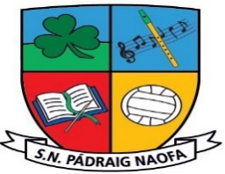

***1st and 2nd Class School Supplies 2024-2025 ~ Ms. Gunning***

|  |
| --- |
| School homework journal, art supplies, photocopying etc. **€25 per child, family of 2 €45, family of 3 or more €60.** |
| 7 A4 Plastic Workbook Covers  3 Copy Covers  Display Folder (20/40 pockets)  2 Card Document Wallet Folders  Activity/Colouring Book for wet days. (This does not need to be new, any one from home is fine.)  3 HB Pencils  1 Red Pen  1 Whiteboard Marker  Eraser, Sharpener, Small Ruler  Twistables  1 Large Pritt-Stick Glue Stick  Tin Whistle - Key of D  Headphones/Earphones – Wired and iPad Compatible (In a Ziplock bag with name.)  Reusable Water Bottle |

**Children in Second Class will have a lot of the above items already from First Class.**

**Please label all belongings sent to school** – pencils, colours, jumper, jacket etc.

**Our School Uniform**

**Navy Jumper with School Crest** V-neck or Round neck (No hoodies)

**Navy Trousers** (not tracksuit)**/Pinafore/Skirt** (Navy tights/Socks)

**Light Blue Shirt/Blouse/Polo shirt**

**Black/Navy Runners** (It is preferable that runners are worn to school every day as they are the safest footwear for the children on the yard.)

On PE days **plain navy tracksuit bottoms** can be worn (No skinnies.)

No clothing with brand names to be worn to school as part of uniform

**School crests for uniform jumpers €5** available in the office.

**School Reopening on Friday 30th August 2024 at 9:10am**