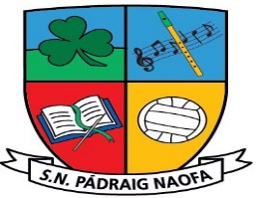

**Fifth and Sixth School Supplies 2024-2025 ~ Mr. Maleady**

|  |
| --- |
| School homework journal, art supplies, photocopying, etc. **€25 per child, family of 2 €45, family of 3 or more €60** |
| **Supplies**  1 x A3 (large) homework folder (zip mesh folder)  1 x display folder (40/ 60 pockets)  5 x A4 plastic workbook covers  10 x plastic copy covers  2 x paper envelope/ document wallet folders  2 x large pritt stick (glue stick)  1 x tin whistle in the key of D  1 x reusable drinks bottle  **Stationery**  2 x whiteboard markers  2 x HB pencils  Eraser  Sharpener  Ruler (30 cm)  2 x red pen  2 x blue pen  2 x highlighter  Twistables  Calculator  Maths geometry set (compass and protractor)  1 x (preferably metal mesh) magazine file holder (to hold books on tables) |

**Our School Uniform**

**Navy Jumper with School Crest** – V-neck or round neck (No hoodies)

**Navy Trousers** (not tracksuits) / pinafore / skirt (navy tights/socks)

**Light Blue Shirt / Blouse / Polo shirt**

**Black/Navy Runners** (It is preferable that runners are worn to school every day as it is the safest footwear for children on the yard for playtime and for PE lessons with teachers and coaches.)

Please label all belongings sent to school - books, uniform, jackets, pens, pencils etc.

PE Days – Plain navy tracksuits can be worn (no brand names, no skinnies.)

**No clothing with brand names to be worn to school as part of uniform**

**School Crests €5 available in the office**

**School reopening on Friday 30th August 2024 at 9:10 a.m.**