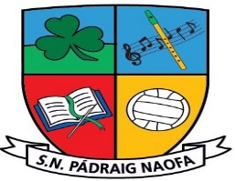

***Junior/Senior Infants School Supplies 2024-2025~ Mrs. Gavigan***

Please label all belongings sent to school - books, uniform, jackets, pens, pencils etc.

|  |
| --- |
| School homework journal, art supplies, photocopying, etc. **€25 per child, family of 2 €45, family of 3 or more €60**  *The school crest is available in the school office and can be ironed or sewn onto your child’s school jumper.* |
| 2 X very durable A3 zip wallet  2 tri-plus learners’ Pencils,  Eraser, Sharpener,  Twistables – the thicker ones (individually labelled) ***No*** *coloured pencils or markers.*  4 black whiteboard markers  1 large Pritt Stick Glue Stick  An old large t-shirt or shirt to wear during art. Large enough to cover uniform. An adult t-shirt is ideal to cover the uniform.  Headphones/earphones (compatible to an ipad) in a sealed Ziplock bag labelled with your child’s name |

**Our School Uniform**

Navy Jumper – V-neck or round neck (No hoodies) (iron on crest available in school office in September)

Navy trousers (no tracksuits) / pinafore / skirt (navy tights/socks)

Light blue shirt / blouse / polo shirt

Black/navy runners(It is preferable that runners are worn every day as it is the safest footwear for children on the yard for playtime and for PE lessons with teachers and coaches.

PE days – plain navy tracksuits can be worn (no brand names) (no skinnies)

**No clothing with brand names to be worn to school as part of uniform**

**School reopening 9:10am Friday August 30th 2024**

**Infants collected from school 1:50pm**

**(New Infants will go home at 12 noon until the 16th September)**